- COURSE: Course #. Course description from college catalog. (Credit hours)

- INSTRUCTOR (S):
Name | Office # | Office Hours | Phone | Email

- SCHOOL OF EDUCATION CONCEPTUAL FRAMEWORK LOGO:
Educators as Reflective Professionals
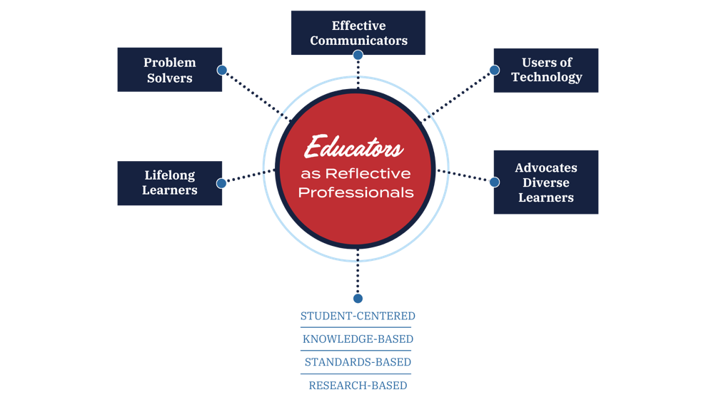

- Vision Statement: We imagine the transformation of individuals and communities to advance educational equity and excellence through innovative practice by professionals who lead and inspire others.

- Mission Statement: The mission of the School of Education is to prepare and engage reflective professionals who create, use and share knowledge in partnership with individuals and communities to serve Mississippi and beyond.

- Unit Major (M) and Minor (m) Themes/Outcomes

  - Lifelong learners who take responsibility for their own learning and continuously foster their professional renewal. ( )

  - Problem solvers who develop solutions to improve the educational environment for all students. ( )

  - Effective communicators who effectively use verbal, non-verbal, electronic, and print modes of communication to establish a positive school environment and promote student thinking and learning. ( )

  - Users of technology who integrate multimedia in learning environments as instructional and management tools to enhance student teaching. ( )

  - Advocates for diverse learners who appreciate, promote, and model the values of diversity. ( )

- KNOWLEDGE BASE MAJOR (M) AND MINOR (m) THEMES:

T—Thinking and problem solving ( )
E—Equality and respect for diversity ( )
A—Appropriate teaching strategies ( )
C—Communication and cooperation ( )
H—Human development and curriculum ( )
E—Esteem, autonomy, and lifelong learning ( )
R—Relevance: social and global ( )
S—Supervision, management, and guidance ( )

- PROFESSIONAL DISPOSITIONS OF CANDIDATES

Teacher Ed Dispositions | InTASC | MCoE | Imagine, Innovate, Inspire | CF
The teacher candidate protects confidential information concerning students and/or colleagues unless the law requires disclosure. | 9 | 9 | Professionalism | Effective Communicators
The teacher candidate demonstrates maturity and sound judgment in all interactions with peers, university and P-12 personnel, and parents. | 9, 10 | 5 | Professionalism  Excellence  Leadership | Life-Long Learners
The teacher candidate  follows all university  and P-12 school policies including but not limited to policies for alcohol, drug, tobacco, and social media use. | 9, 10 | 6 | Professionalism  Leadership | Life-Long Learners  Effective Communicators
The teacher candidate exemplifies honesty and integrity (honesty, tact, and fairness) with all stakeholders during his/her time in the program. | 9 | 2 | Excellence  Professionalism | Effective Communicators  Problem Solvers
The teacher candidate  accepts constructive criticism in a positive manner. | 9 | 1 | Excellence  Transformation | Effective Communicators  Problem Solvers
The teacher candidate provides fair and equitable opportunities for all P-12 students in a non-discriminatory manner. | 1, 2, 8 | 4 | Caring, Equality, Authentic Assessment | Advocates for Diverse Learners  Effective Communicators  Users of Technology
The teacher candidate maintains a professional relationship with all students both inside and outside professional settings. | 10 | 4 | Professionalism  Collaboration  Excellence | Life-Long Learners  Effective Communicators

- COURSE TEXTS/MATERIALS:
  - Required Text(s)/Readings:
  - Supplemental Text(s)/Readings:

- PURPOSE OF THE COURSE:

- COURSE OBJECTIVES: [List the number that corresponds to the standard(s) related to each objective. The third column of the table should be used for content standards (CAEP-Elementary, NCTE, NCTM, NSTA, CEC, etc.]

Candidates will be able to:
Objectives | InTASC | CRT

- COURSE OUTLINE:

- COURSE REQUIREMENTS, POLICIES, AND EVALUATION PROCEDURES:

  - Course Requirements

  - Assessment Procedure (UM Policy #10000265)

    - Examples:

      - Participation in weekly assignments (includes articles, reflection assignments, discussion & attendance) (25 points)

      - Affirmative Action Paper (20 points)

      - Group Project on ADA and Section 504 (25 points)

      - Final Group Research Paper & Presentation Relating to Culture (30 points)

Presentation, projects, and test will be used to determine candidate achievement of the course objectives listed under VI. All required assignments will be given a specific grade. Grades will be computed using the following scale:

Grade | Percentage Required
A | 93%-100%
A- | 90%-92%
B+ | 87%-89%
B | 83%-86%
B- | 80%-82%
C+ | 77%-79%
C | 73%-76%
C- | 70%-72%
D | 60%-69%
F | 0%-59%

  - Field Experience and Clinical Practice

  - Instructional Strategies

  - Attendance Policy (UM Policy #10000265)

All Syllabi must reflect an attendance policy.

    - Examples:

      - Attendance and participation in class are expected. An excessive number of absences will adversely affect the final grade for the course.

      - Attendance and participation in class are expected. Candidates are responsible for all material covered when absent. Three or more absences will result in lowering the final grade one letter grade.

      - Attendance and participation in class are expected. Excessive absences (more than one) will adversely affect the final grade for the course. Each additional absence results in a 5-point deduction from the final grade for this course. Candidates are responsible for all material covered when absent.

  - Policies Related to Students (Candidates) with Disabilities

Disability Access and Inclusion:
The University of Mississippi is committed to the creation of inclusive learning environments for all students. If there are aspects of the instruction or design of this course that result in barriers to your full inclusion and participation or to accurate assessment of your achievement, please contact the course instructor as soon as possible. Barriers may include, but are not necessarily limited to, timed exams and in-class assignments, difficulty with the acquisition of lecture content, inaccessible web content or the use of non-captioned or non-transcribed video and audio files. Students must also contact Student Disability Services at 662-915-7128 so that office can 1) provide you with an Instructor Notification form, 2) facilitate the removal of curricular barriers, and 3) ensure you have equal access to the same opportunities for success that are available to all students.

- SPECIAL CONSIDERATIONS

  - Academic Integrity and Honesty – Candidates are expected to follow the honor code as outlined in the current University of Mississippi M Book, which can be found online at http://conflictresolution.olemiss.edu/wp-content/uploads/sites/2/2014/09/MBOOK20153.pdf. Plagiarism, as defined in the honor code, will not be tolerated.

  - Writing Center – Aside from one-on-one meetings with teachers during office hours, a great way to improve your writing is to work with writing consultants at one of the University’s writing centers. Writing consultants will work with any student writer working on any project in any discipline. To learn more about the writing center locations, hours, scheduling and services, please go to rhetoric.olemiss.edu/writing-centers/

Graduate Writing Center, Lamar 405 (Oxford Campus)
662-915-3173 gwc@olemiss.edu

Tupelo Writing Center, Room 261 (Tupelo Campus)
662-915-6259 writingcentertupelo@olemiss.edu
Oxford Campus Writing Center, Suite C, Lamar Hall
662-915-7689 cwrwc@go.olemiss.edu

Desoto Writing Center, Library (Desoto Campus)
662-280-6209 writingcenterdesoto@olemiss.edu

  - Flexibility Clause – The aforementioned requirements, assignments, policies, evaluation procedures, etc., are subject to change. Candidates’ experiences and needs, as well as emerging knowledge, will be considered in modifying this course syllabus.

